Document code : ENI-VMS-U716-06

Revision : 02

Creation date : 15/06/2015

Date of last revision : 15/02/2016

**”VMS User Manual” extract for Contract Holder**

**TABLE OF CONTENTS**

1.1 “Manual” launch of the Performance Evaluation Processes for the Execution Phase 6

1.1.1 Manual Entry of Contracts 6

1.1.2 Create Evaluation Request for Execution Phase 9

1.1.3 Request for Compilation of Evaluation Questionnaire for Execution Phase 13

1.2 Compilation of the Evaluation Questionnaires for Execution Phase 15

1.2.1 Questionnaire Header Data 15

1.2.2 Offline compilation of the Evaluation Questionnaire 19

1.3 Approval workflow of Evaluation Questionnaires for Execution Phase 20

1.3.1 Sending for Approval 20

1.3.2 Approval or Rejection of an Evaluation Questionnaire 21

1.3.3 Log Approve 22

1.4 Evaluation Questionnaire for Execution Phase working lists 23

1.4.1 List of Approved Evaluation Questionnaires by Compiler 23

1.4.2 List of Evaluation Questionnaires by Unit Manager and by Compilers 24

1.4.3 List of Evaluation Questionnaires for Execution Phase by Vendor Rating Unit 24

1.4.4 List of Evaluation Questionnaires for Execution Phase by Vendor Rating Unit with scores 26

1.4.5 Forwarding or Setting Questionnaires to Obsolete 26

1.4.6 Supplier Form for the Execution Phase 28

1.5 Evidence for Activation of Evaluation Team 28

To Creating new evidence: 29

# PURPOSE OF THIS DOCUMENT

The aim of the document is to provide users of the new VMS system with useful information for the proper use of the functions implemented for the management of the Supplier Performance Evaluation Processes.

# Landscape of reference

Below is the Landscape of Reference for the VMS project



# PROCESSES COVERED BY THE SYSTEM

Management of the Performance Evaluation Processes will enable Vendor Rating Indicators to be obtained, representing the qualitative level of Supplier services, analysing their performance in the “tender phase” and “execution phase”.

The Feedback Processes will make it possible to adopt Measures, resulting in the update of the Supplier Status in the VMS and in the Transaction Systems.

# ACCESS TO THE VMS SYSTEM

To login to the system, launch the browser and use the following URL:

[https://ssosap.eni.com/public/goto**FL**.html?SSOSAPPARAMS=https://buy.eni.com](https://ssosap.eni.com/public/gotoFL.html?SSOSAPPARAMS=https://buy.eni.com)

Access to the VMS system will be made through Single Sign On. Therefore the USER ID and password will not be requested.

After logging into the system, a screen like the one below will be displayed.

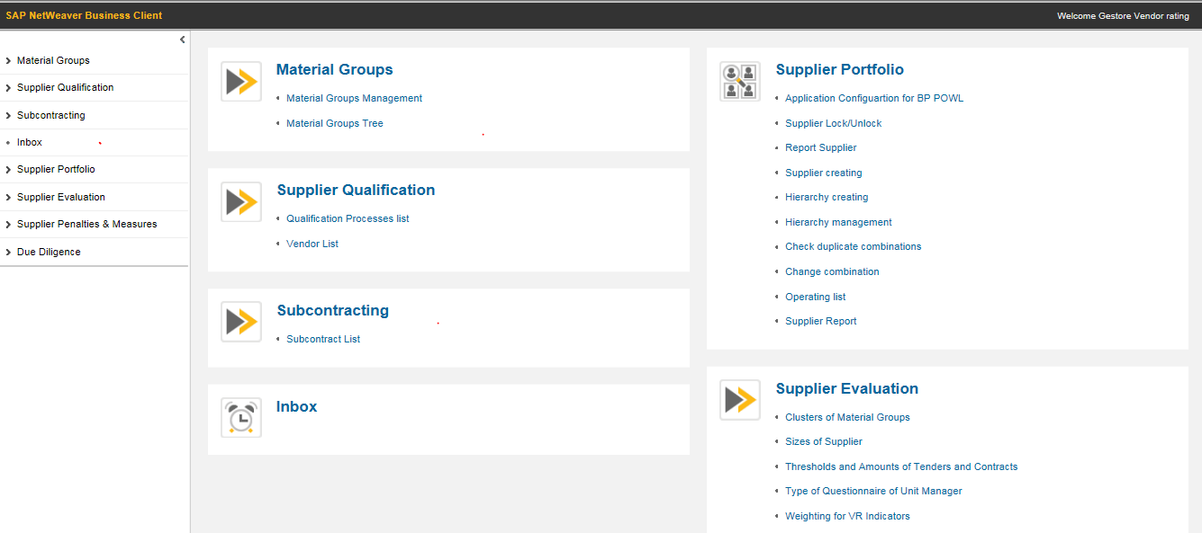

***Menu***

***Home page***

On the left side of the screen (menu), a summary of all the user profile functions are shown, grouped in the form of “resource management” (or tree menu); using dedicated icons, the various groupings can be expanded or collapsed.

The same functions specified on the left side of the screen are shown in the right section in expanded form (**home page**).

Placing the cursor over the various listed services, the link will be highlighted to indicate the selection: by clicking the mouse a new screen will open for the selected service.

## “Manual” launch of the Performance Evaluation Processes for the Execution Phase

In the qualification and profiling phase for Compilers and Approvers of Execution Phase Questionnaires, it is possible specify a number of Compilers and Approvers for the same Unit Manager.

Every VMS User enabled as Compiler of Execution Phase Questionnaires will have access to the Contract List service for their Unit Manager. From this List they can:

* manually enter Contracts for their Unit Manager, in addition to those received via interface with SIA and GPS (“Contracts” List);
* start filling out Evaluation Questionnaires (“Compile Questionnaire” button on the contracts of their Unit Manager (“Contracts” List);
* compile the existing Questionnaires if they are not already partially or fully compiled by other Compilers of their Unit Manager (“Evaluation Questionnaires for Unit Manager” List); in other words, a “Compiler” can open and fill in the Questionnaires only if he is a “Compiler” or is temporarily assigned to the “dummy compiler”.

**Note**: Users with the role of Vendor Rating Manager continue to be able to request the compilation of the Questionnaire for all contracts in the VMS database. The message confirming the creation of the Evaluation Request.

### Manual Entry of Contracts

To enter a contract manually it is necessary to:

1. Launch the service from the menu “Vendor Ratings” > Contract List

2. Create a new entry by clicking on the  icon

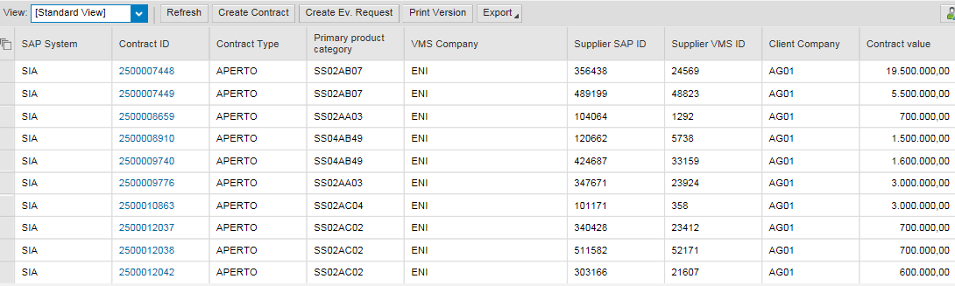

The Contract List in the VMS is the tool:

1. ***to enter new Contracts, in addition to those from SIA and GPS, compiling the following fields:***

|  |  |  |  |
| --- | --- | --- | --- |
| **Field** | **Description** | **Notes** | **Mandatory** |
| Contract ID | An ID must be provided that uniquely identifies a Contract for the Customer Company | 10-digit alphanumeric code | Yes |
| Contract Type | It is necessary to indicate the Contract Type | Controlled field with list of possible values ​​(Open/Closed) | Yes |
| Primary Product Category | It is necessary to indicate the Primary Product Category for the Contract | Field-level help is available to start the search by …. | Yes |
| Supplier SAP ID | It is necessary to specify the Supplier SAP ID for the Contract | Field-level help is available to start the search by Company Name and part of the SAP Code | Yes |
| Supplier VMS ID | It is necessary to specify the VMS Supplier ID for the Contract | Field-level help is available to start the search by Company Name and part of the SAP Code. The VMS will fill in the Field according to the Supplier SAP ID. | Yes |
| VMS Company |  | The VMS will suggest the Company Name of the Vendor based on the Supplier SAP ID. | Yes |
| Contract Value/Currency | It is necessary to specify the Contract Value in the Currency |  | Yes |
| Contract Value in Euros | It is necessary to specify the Contract Value in Euros |  | Yes |
| Approval Date | It is necessary to specify the Contract Approval Date | The Calendar Utility will be available | Yes |
| Valid From | It is necessary to specify the Contract Validity Start Date | The Calendar Utility will be available | Yes |
| Valid To | It is necessary to specify the Contract Validity End Date | The Calendar Utility will be available | Yes |
| Nr. Revision | It is necessary to specify the Contract Revision Number | The Calendar Utility will be available | Yes |
| Nr. Version | It is necessary to specify the Contract Version Number | The Calendar Utility will be available | Yes |
| Note | It is possible to insert a Note | Text Field | No |
| Description | It is possible to enter a Description | Text Field | No |
|  |  |  |  |
| Client Company | It is necessary to indicate the Client Company |  | Yes |
| Unit Manager | It is necessary to indicate the Unit Manager |  | Yes |

When saving the data, the VMS will autofill the following Contract information

|  |  |  |
| --- | --- | --- |
| **General information** |  |  |
| **Field** | **Description** | **Notes** |
| SAP system |  | The VMS will automatically enter MAN (manual) |
| Author | UserID, Full Name of the User who created the Contract | Autofilled by the VMS |
| Creation date | Date of Contract Entry | Autofilled by the VMS |

***Uniqueness Checks:*** it will not be possible to enter multiple contracts with the same combination of Contract ID/Nr. Revision/Nr. Version/Client Company

***Data Changeability:*** a Contract entered manually cannot be changed or deleted if the Evaluation Processes have already been launched

1. ***Search/verification of contracts in the system (manual and uploaded via interface)*** applying appropriate filters
2. ***Excel export*** of the entire list through the  button
3. ***Contract Deletion:*** Within the Contract tab, the  function key allows the cancellation of the created ID. Before deletion, the system checks that the contract ID in question does not have an Active Evaluation Process.

### Create Evaluation Request for Execution Phase

It is possible to launch the Evaluation Processes for the Execution Phase by selecting one of the Contracts in the list and using the “Create Ev. Request” function.

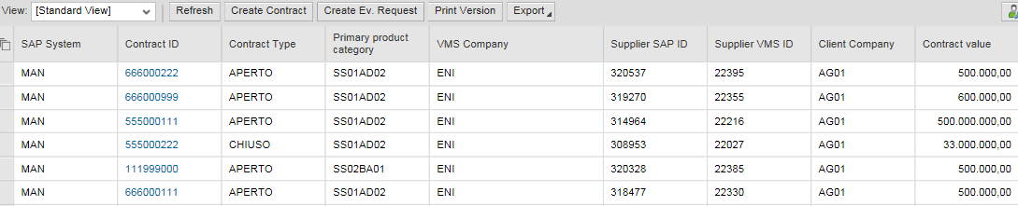

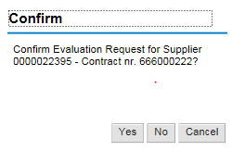

When the function is launched, the VMS will try to deduce:

1. the correct Evaluation Form based on:
   1. the type of Evaluation: the Questionnaire will be for the Execution Phase if the process is launched from the “Contract List”;
   2. the type of Questionnaire (Standard or Simplified): the suggested type of Questionnaire will be that provided for the Unit
   3. the GM Cluster code: starting from the Primary Product Category of the Contract, the VMS will verify the associated Cluster code in the GM Register and will deduce the correct Form;
2. The possible Compilers of the Evaluation Questionnaire: the VMS will deduce the Compilers based on the Contract Unit Manager

After processing is complete, the VMS:

* will confirm the creation of the Evaluation Request, returning the sequence number that will identify it and the Compilers of the Contract Unit Manager.



In real time, an Evaluation Request email will be sent to the Questionnaire Compiler, containing a URL that will allow him to open the Questionnaire web page to be filled in if the recipient of the email considers the contract to fall under his evaluation responsibility.

The System will not allow the simultaneous processing of the same Questionnaire; when a compiler opens the Questionnaire, makes a change and saves it, the VMS will not allow compilation of the Questionnaire by other users.

* an “error message” will report the inability to start the process due to the failure to deduce the Form and/or Compiler. It will be possible to repeat the Creation of the Evaluation Request only after the necessary information has been formalized in the VMS.



The compiler of the Unit Manager will receive a notification with the request to compile a specific Questionnaire (shown below).

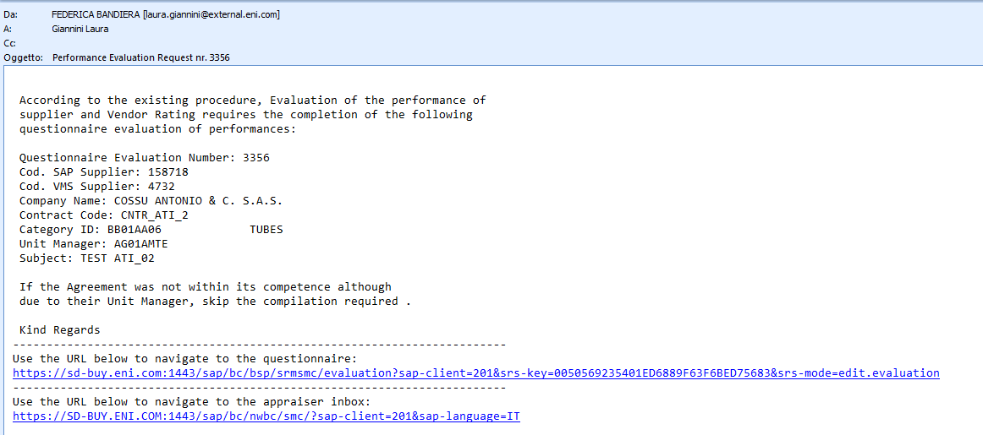

Alternatively, the Compiler can access the Questionnaire from the “List of Evaluation Questionnaires by Unit Manager”, which will contain a list of all manually or automatically generated Questionnaires by Unit Manager Contracts relevant to the user with a “Contract Manager” profile.

All Compilers by Unit Manager can participate in the compilation of the Questionnaire, but when a compiler opens the Questionnaire, makes a change and saves it, the VMS will not allow the opening and compilation of the Questionnaire by other users of the same Unit Manager, who will see in the “Compiler” field the name of the person who is working on it.

If another Compiler of the same Unit Manager tries to open the Questionnaire, the system will generate the following warning:

*”Error: You cannot edit the questionnaire; it is locked by Compiler Name and Surname”.*

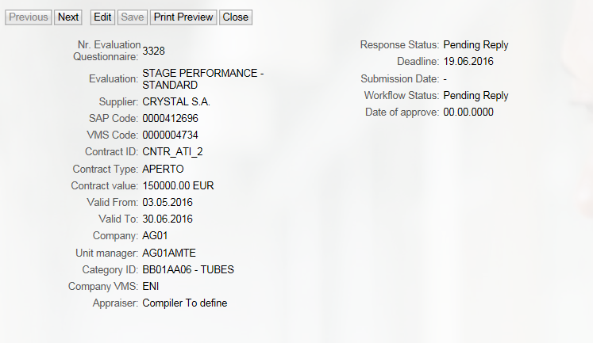

1. The Questionnaire created for the unit manager has not yet been taken over by any compiler.

The author of the evaluation is still **“Compiler to define”**

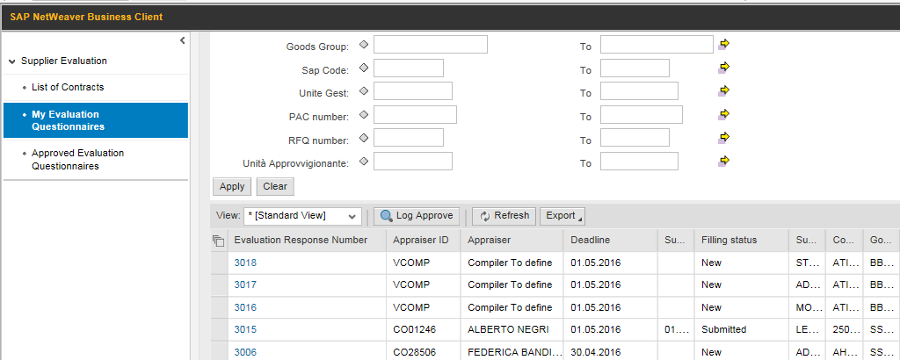

2. The Compiler can also start compiling the questionnaire from the “Evaluation Questionnaires for Unit Manager” list.

(Double-click on the process number).

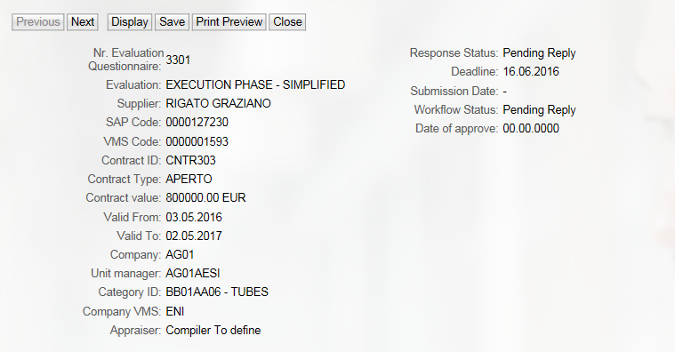

3. The Compiler “takes charge” of the questionnaire when he first saves something in it.

4. After saving it for the first time, the author of the evaluation will change from “Compiler to define” to “Name and Surname of the Contract Manager” (in our case Contract Manager).

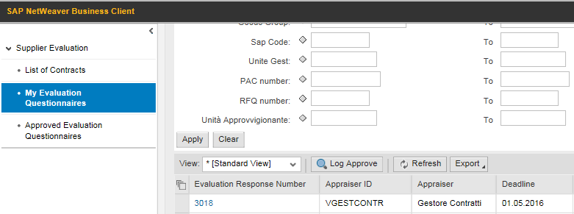

If, however, the Contract Manager starts a detailed compilation of an Evaluation Questionnaire (“Compile Questionnaire” button on the contracts of his Unit Manager (“Contracts” List), the Questionnaire is directly assigned to him as the author of the evaluation.

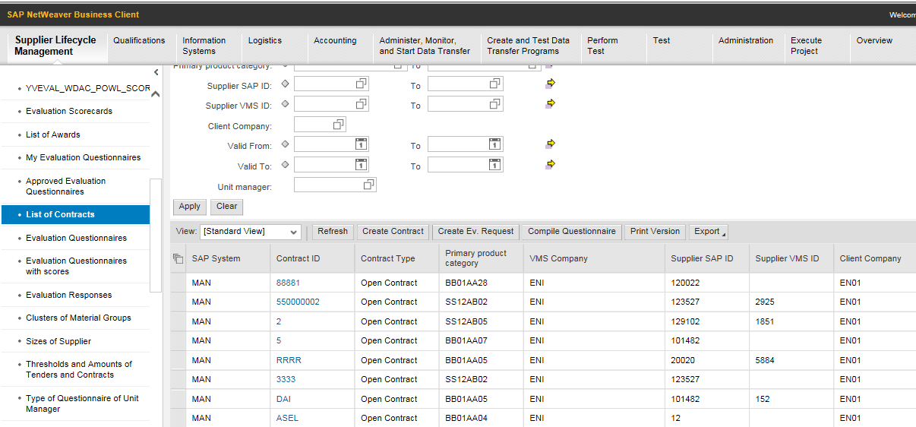

1. From the Contract List, the Contract Manager starts compiling the Questionnaire directly.

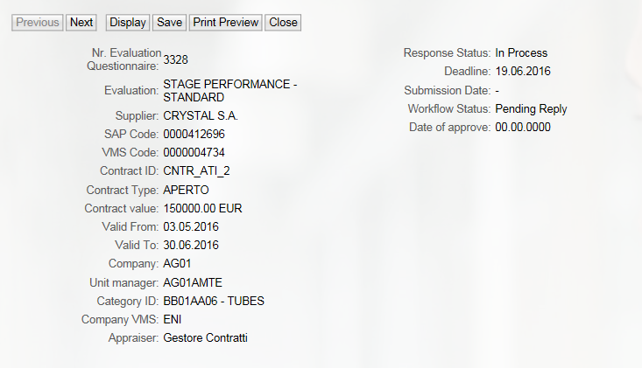

### Request for Compilation of Evaluation Questionnaire for Execution Phase

All Compilers authorized to use the VMS may decide to fill out Evaluation Questionnaires starting from the Contract List (appropriately filtered by Unit Manager), selecting one of the existing Contracts (by Unit Manager of the Compiler) and launching the “Compile Questionnaire” function. In this case the Questionnaire will be assigned directly to the Contract Manager who performed the activity.

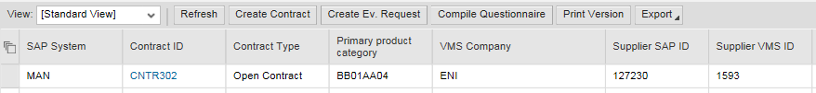

The VMS will try to deduce:

1. the type of Evaluation: the Questionnaire will be for the Execution Phase if the process is launched from the “Contract List”;
2. the type of Questionnaire (Standard or Simplified): the suggested type of Questionnaire will be that provided for the Unit Manager
3. the GM Cluster code: starting from the Primary Product Category of the Contract, the VMS will verify the associated Cluster code in the GM Register and will deduce the correct Form;
4. The compiler of the Questionnaire (name and surname in the “author of the evaluation” field)



After processing is complete, the VMS

* will open the web page for compilation of the Questionnaire

or

* an “error message” will report the inability to start the process due to the failure to deduce the Form and/or Compiler. It will be possible to repeat the Compilation Request only after the necessary information has been formalized in the VMS.

## Compilation of the Evaluation Questionnaires for Execution Phase

### Questionnaire Header Data

Following a Request for Evaluation or at his own discretion, the Compiler will have the opportunity to compile the online Evaluation Questionnaire, being able to deduce the subject of Evaluation from the Questionnaire Header Data itself:

* Number of the Evaluation Questionnaire
* Contract ID
* Contract Type
* Primary Product Category
* Supplier SAP ID
* Supplier VMS ID
* VMS Company
* Contract Value in Currency
* Contract Value in Euros
* Approval Date
* Valid From
* Valid To
* Client Company
* Unit Manager

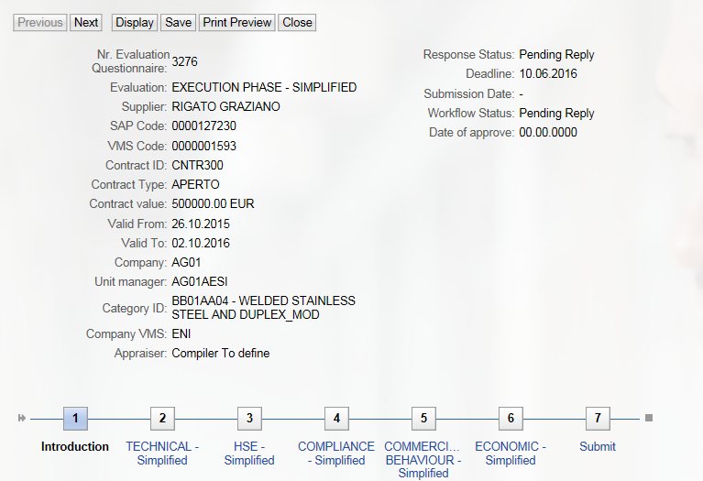

The  button allows you to scroll through the various points from 1 to 7 to complete the all parts of the Questionnaire.

For instance, compiling the Execution Phase Technical Questionnaire:

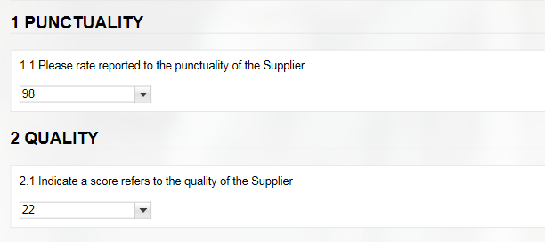

Questions must be answered with YES or NO or No Indication (where possible), and a response is mandatory for those marked with a red asterisk.

A comment can also be added, if deemed necessary.

By scrolling through the various questionnaires and answering the questions, you reach point 7, the point of sending for approval.

It is possible to have more than one Approver per Unit Manager.

At point 7, the Questionnaire Compiler will have to choose from the drop-down menu the name of the Approver to whom he wants to send the Questionnaire for approval.

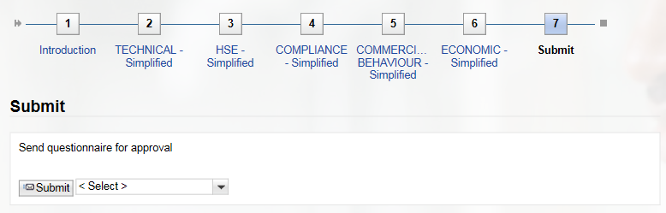

If no Approver name is selected from the menu, the system will display a fatal error message:



Once the Approver has been selected, clicking the  button sends the Questionnaire for the approval of the Manager.

The “compiler” user can choose the Questionnaire Approver, by selecting from among the Approvers of their Unit Manager, and he will be responsible for the responses saved up to that point.

The Manager will receive an email containing a URL to open the Questionnaire web page, to check the Questionnaire and for its Approval/Rejection.

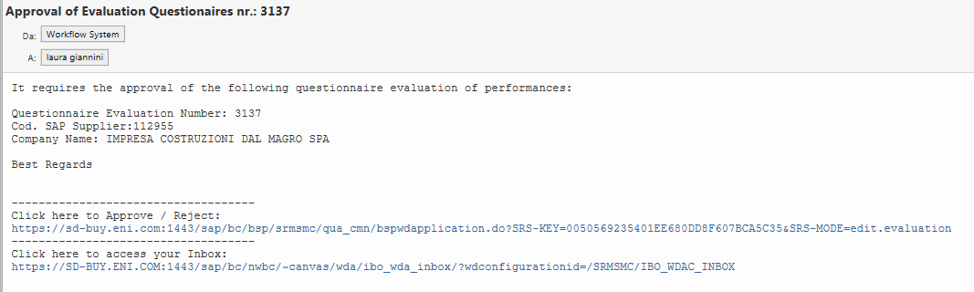

By clicking on the link, the Manager can view all parts of the process, including any attachments, and at point 7) he always has the option to approve or reject the Questionnaire.

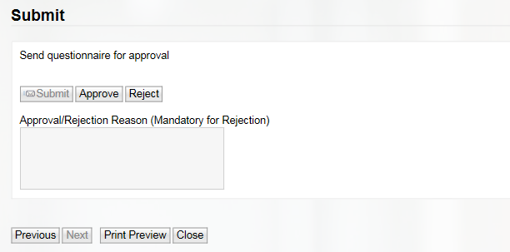

In the case of rejection, it is mandatory to enter a reason for the rejection or the system will display the following fatal error message:



Moreover, in the case of Rejection of a Questionnaire, a rejection notification email will be sent to the User who sent the Questionnaire for Approval (same as in the case of approval).

Questionnaires that are rejected and once again have a “still no response” status can only be modified by the Compiler who sent it for Approval, and they may be submitted for approval to all approvers of the Unit Manager.

Regarding the HSE portion, the answer to the Questions can be “1,2,3,4,5, or no indication”, representative of the statements in an HSE Questionnaire in Excel format, managed (circulated and compiled) outside the VMS. This Excel file must be attached (there will be a system check) to the entire Evaluation Questionnaire managed in the VMS by the “compiler”.

### Offline compilation of the Evaluation Questionnaire

The Evaluation Questionnaires can be completely compiled offline (full VMS Evaluation Form) or in part (individual VMS Questionnaires for calculating the Level I Indicator: Technical, Compliance, Business Conduct, Financial), in order to delegate its compilation outside the system, after downloading it.

The result of the download is an Excel file consisting of several sheets:

* one sheet will contain the header data of the Evaluation Questionnaire.
* one sheet for each Questionnaire (Technical, Compliance ....etc.); the sheets will be different if the entire VMS Form is downloaded; one sheet if an individual VMS Questionnaire is downloaded.

**Exporting the entire VMS Evaluation**

1. Click on the “Export Model” button, and select the path for saving the file.

2. Compiling the questionnaire outside the system.



Select

4. Click on the “Import Model” button to upload the Questionnaire compiled offline to the VMS

3. Click “Select” to retrieve the file that was just compiled outside the system

**Exporting the individual VMS Questionnaire:**

2. Compiling the questionnaire outside the system.

1. Click on the “Export Questionnaire” button, and select the path for saving the file.

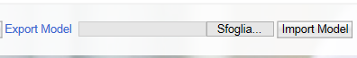

Select

4. Click on the “Import Questionnaire” button to upload the Questionnaire compiled offline to the VMS

3. Click “Select” to retrieve the file that was just compiled outside the system

The Excel file will list the individual questions; in detail:

* the sequential identifier, the text, the explanation, and the type of question;
* the compilation instructions, based on the type of question;

The Excel sheet can be compiled by entering:

* an X next to one of the available responses
* a comment.

After compiling the Excel spreadsheet, it is possible to upload the Evaluation Questionnaire (in full or in parts, as described above).

In this phase, consistency checks with the types of questions will be carried out: for example, if a single-selection question is given two or more answers, the VMS will not update the Evaluation Questionnaire or parts of it in the VMS.

## Approval workflow of Evaluation Questionnaires for Execution Phase

### Sending for Approval

After compilation, the Compiler can send the Evaluation Questionnaire “for approval”.

The “Compilation Status” of the Evaluation Questionnaire will change to “Returned”.

The “Compilation Status” of the Evaluation Questionnaire will change to “For Approval”.

The VMS will submit the Evaluation Questionnaire to the Approver, identified according to what was declared for the Unit.

If the VMS cannot determine the Approver's UserID due to the absence of the information for the Unit, the Evaluation Questionnaire will remain in a “Returned” status and the Compiler will see an “error message” in identifying the Approver.

Following the formalization of the Approver for that specific Unit Manager, the Compiler can again proceed to Send for Approval.

In real time, an Approval Request email will be sent to the Questionnaire Approver, containing a URL that will allow him to open the web page of the Questionnaire for Approval. Alternatively, the Approver can access the Questionnaire from the “List of Evaluation Questionnaires”, suitably filtered, and proceed with the Approval.

### Approval or Rejection of an Evaluation Questionnaire

The Approver of the Evaluation Questionnaires can access the List of Questionnaires to Approve and make selections for:

The Approver can view the Evaluation Questionnaire, but cannot change the Answers.

The Approver can add Comments on an individual Answer level.

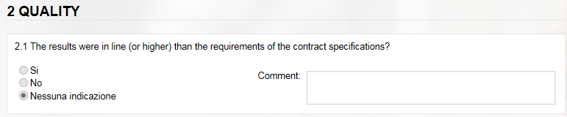

The Approver can:

* ***approve the Evaluation Questionnaire***: in this case the Evaluation Process will be concluded and the Questionnaire scores will contribute to updating the Vendor Rating Indicators (provided that the condition of the Contract that the Questionnaire refers to is “significant”); the Approval Status of the Questionnaire will change to “Approved”;
* ***reject the Evaluation Questionnaire:*** in this case, the Evaluation Questionnaire will be resubmitted to the Compiler who sent it for Approval and

who can change the Answers given, on the basis of specific Comments on individual answers or the Reason for Rejection that the Approver must enter during the approval process, and resubmit for approval to one of the approvers of his unit manager.

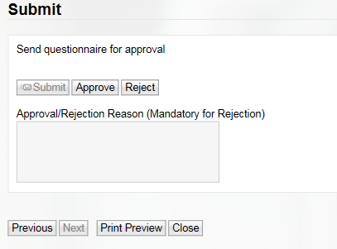

The Evaluation Process will only end when the Evaluation Questionnaire is approved.

### Log Approve

From the List of Approved Evaluation Questionnaires it is possible to view the list of approval steps that any particular Evaluation Questionnaire underwent.

Using the “Log Approve” button:

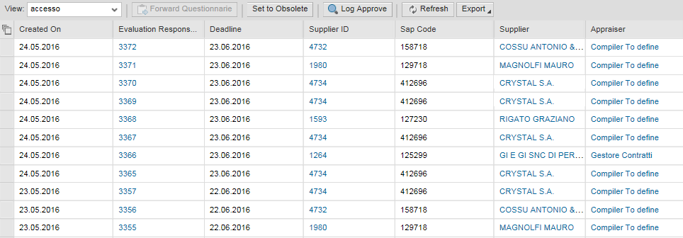

The SAP screen containing the Approval Workflow Log opens, which identifies the author of the approval/rejection, date and time, and rejection notes.

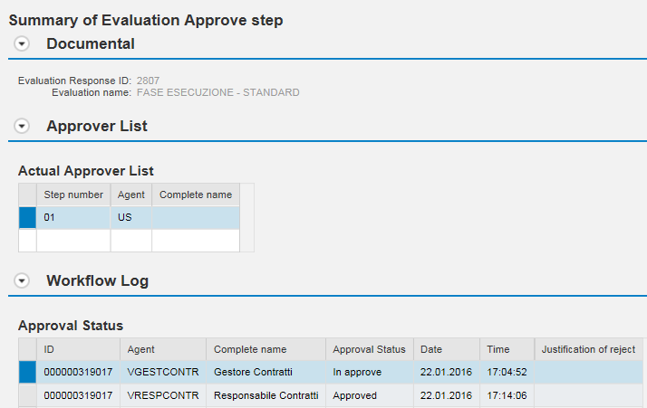

## Evaluation Questionnaire for Execution Phase working lists

### List of Approved Evaluation Questionnaires by Compiler

The compilers will have access to a working list, where they may track the Evaluation Questionnaires, i.e. all the Approved Evaluation Processes.

Launch the “Evaluation Questionnaires” service:

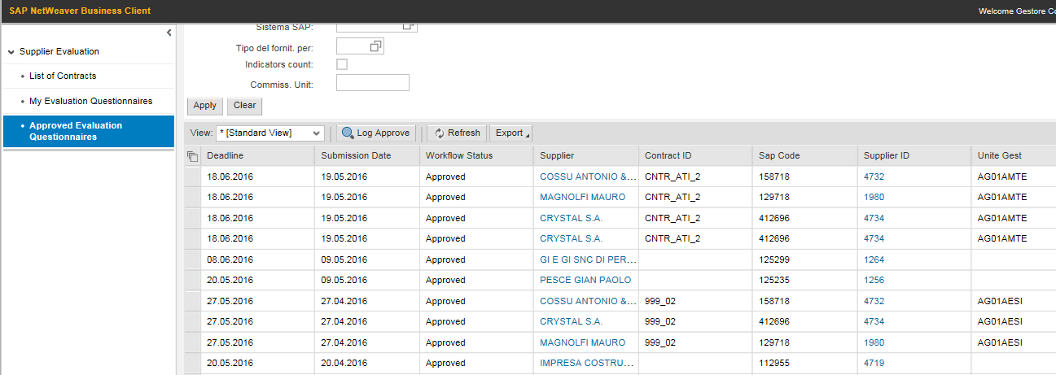

The display of the output, the various information, and the ordering of the fields can be customized by the user, who can save a Launch Variant to always return to the user’s own default layout as described in *section 5.8.1*.

The contents of the Lists can be exported to Excel using the  button.

### List of Evaluation Questionnaires by Unit Manager and by Compilers

The list of “Questionnaires by Unit Manager” contains a list of all manually or automatically generated Questionnaires for the Contracts of the Unit Manager that the user belongs to.

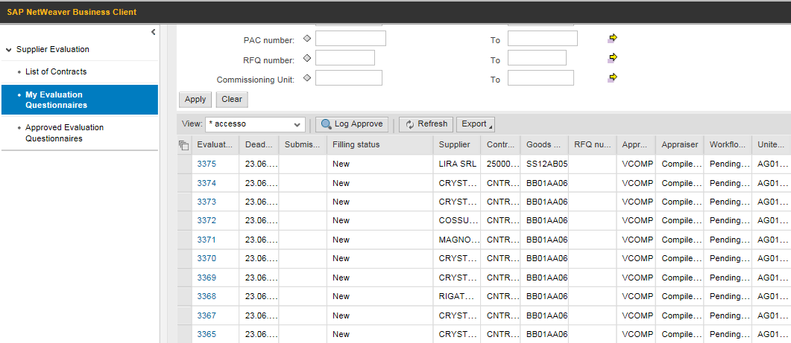

As stated above, the display of the output, the various information, and the ordering of the fields can be customized by the user, who can save a Launch Variant to always return to the user’s own default layout.

The contents of the Lists can be exported to Excel using the  button.

### List of Evaluation Questionnaires for Execution Phase by Vendor Rating Unit

Vendor Rating Unit will also have access to a working list where they can track the Evaluation Questionnaires.

Unlike the Compilers, the Vendor Rating Unit will see all the Evaluation Processes, including those not Approved.

Launch the “Evaluation Questionnaires” service:

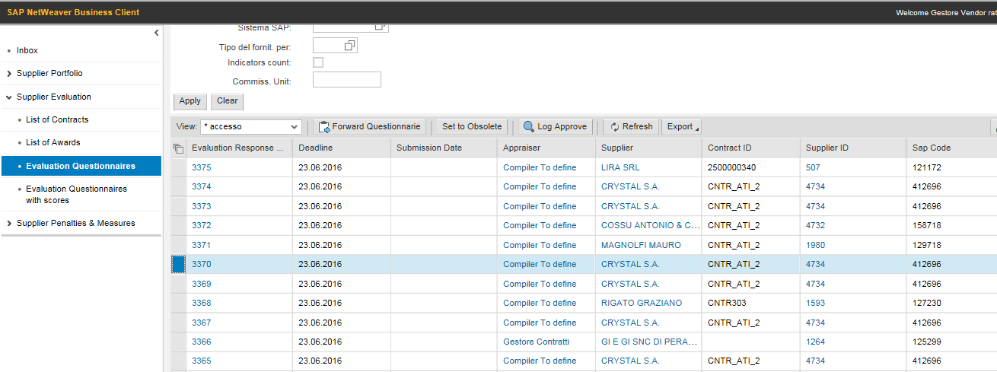

The following table shows the input and output information of the Questionnaires List:

|  |  |  |  |
| --- | --- | --- | --- |
| **INFORMATION** | **Possible values** | **Search criteria** | **Output field** |
| Number of the Evaluation Questionnaire |  | Yes | Yes |
| Evaluation Author (UserID) |  | Yes | Yes |
| Evaluation Author (Name and Surname) |  |  | Yes |
| Unit Manager of the Evaluation Author |  | Yes | Yes |
| Request Creation Author (UserID) |  | Yes | Yes |
| Request Creation Author (Name and Surname) |  |  | Yes |
| Supplier VMS ID |  | Yes | Yes |
| Supplier SAP ID |  | Yes | Yes |
| Supplier Name |  |  | Yes |
| Contract ID |  | Yes | Yes |
| Primary Product Category |  | Yes | Yes |
| Creation date |  | Yes | Yes |
| Expiry date |  | Yes | Yes |
| Compilation Status | No Answer Yet  Returned | Yes | Yes |
| Approval Status | For approval  Approved  Rejected  Obsolete | Yes | Yes |

### List of Evaluation Questionnaires for Execution Phase by Vendor Rating Unit with scores

Vendor Rating Unit also have access to a working list showing the various scores of the Form and the Questionnaire.

Launch the “Evaluation Questionnaires with Scores” service:

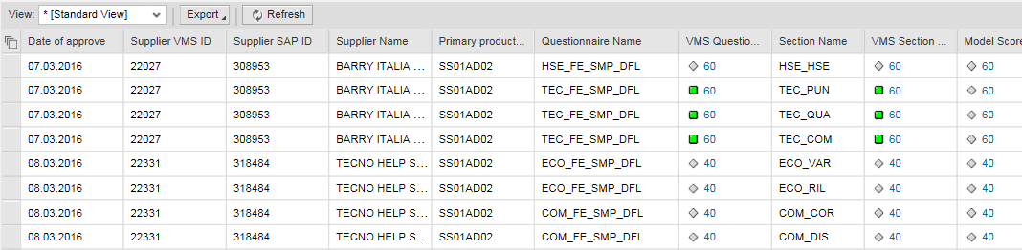

### Forwarding or Setting Questionnaires to Obsolete

The Vendor Rating Unit, can perform two activities on the Evaluation Questionnaires for the Execution Phase that have not yet been compiled:

* “Forwarded” to a different Compiler

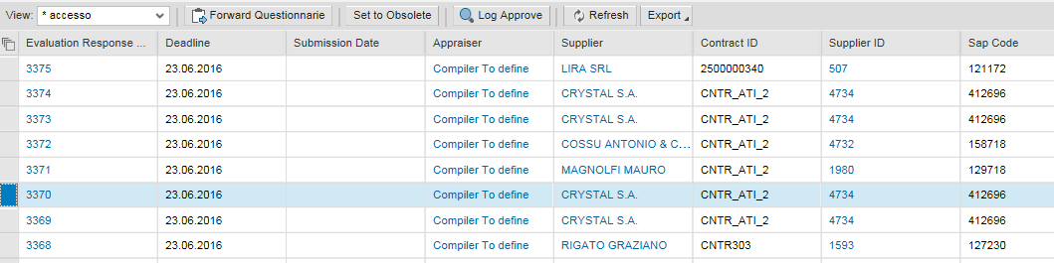

Selecting the “Forward Questionnaire” button opens the following screen, on which it is necessary to:

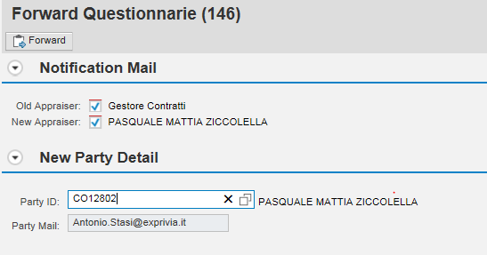

2. Search for the new compiler among the compiler match codes. Once the party ID is shown in the box provided, press “ENTER” on the keyboard to automatically display the email address.

1.The Old and New Appraiser flags to notify the compiler change are set by default by the system. If you do not want to send the notification to either one, you must uncheck the flag.

* “set to obsolete”



By selecting the “Set to Obsolete” button, the following screen opens, where the reason must be entered and confirmed.

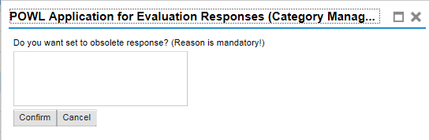

These functions are for the exclusive use of the Vendor Rating Unit.

### Supplier Form for the Execution Phase

The supplier form includes an “Evaluations” tab dedicated to the Vendor Evaluation Process. The Supplier form shows:

* the list of Approved Evaluation Processes
* the following indicators:
  + IVR: Summary performance evaluation indicator and penalties for a vendor
  + IVR (Area): Summary performance evaluation indicator and penalties for a vendor in a specific evaluation area
  + ISP: Summary performance evaluation indicator and penalties for a vendor (no penalties)

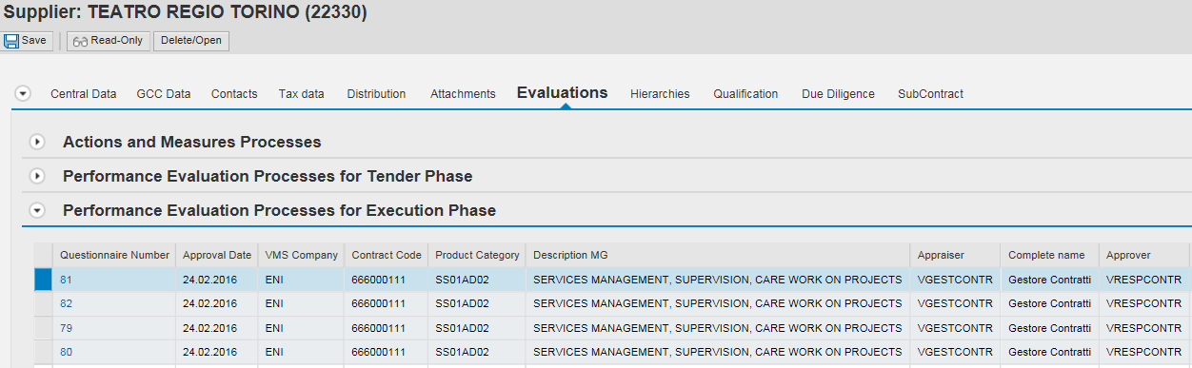

## Evidence for Activation of Evaluation Team

This function allows Evidence to be created following after “Misconduct” or “Non-performance Feedback”, in relation to a particular Vendor.

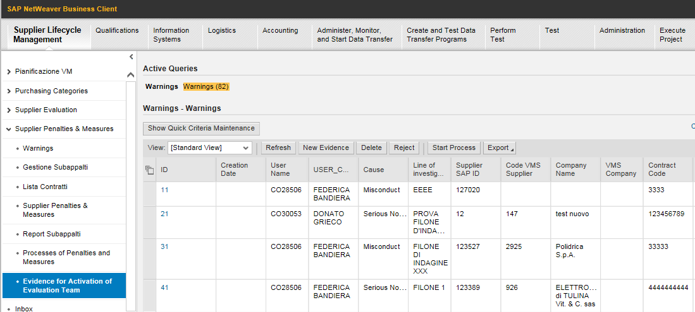

### To Creating new evidence:

1. Launch the service from the menu “Penalties and Measures > Evidence for the Activation of Evaluation Team

2. Create a new entry by clicking on the  icon

3. Enter the necessary information by entering:

|  |  |  |  |
| --- | --- | --- | --- |
| **General information** |  |  |  |
| **Field** | **Description** | **Notes** | **Mandatory** |
| Cause | The Cause can be specified | Controlled field with a list of possible values:   * Misconduct * Non-performance * Other | Yes |
| Type of Finding | The source of information can be specified | Controlled field with a list of possible values:   * Press Release * Internal Evidence * Due Diligence - Tender * Due Diligence - Contract * Due Diligence - Qualification * Other | Yes |
| Line of Investigation | It is possible to add a text element which, used as selection criteria in the evidence list, allows more than one to be retrieved, referring to several vendors, but for example relating to the same offence/breach. | Text Field | Yes |
| VMS Company | It is possible to specify the VMS Company that the Evidence refers to | It is possible choose from among the managed VMS Companies | Yes |
| Context of Finding | It is possible to enter a descriptive text of the context in which the compiler became aware of the material breach or offence | Text Field | No |
| Description of the Offence or Material Breach | It is possible to enter a brief description of the detected event | Text Field | No |
| Description of Business Impacts | It is possible to enter the impacts on the business, if any | Text Field | No |
| Suggested or adopted solutions | It is possible to indicate any solutions identified by the supplier; specify whether the supplier was not able to offer solutions and if the customer had to intervene | Text Field | No |
| **Supplier Information** |  |  |  |
| **Field** | **Description** | **Notes** | **Mandatory** |
| Supplier SAP ID | SAP Code of the Supplier | It is possible to search for the Supplier SAP ID with a partial SAP Code and Company Name | Yes |
| Code VMS Supplier | The VMS Code of the Supplier | It is possible to search for the Code VMS Supplier with a partial SAP Code and Company Name Alternatively, the VMS will autofill it, starting from the SAP Code | Yes |
| Supplier Name | Company name of the reported Supplier | The VMS will autofill it, starting from the SAP Code | YES |
| Contract ID | Code of the Contract that the Supplier breached | The Contracts that can be referred to will be those of the internal VMS database, populated from the SIA/GPS interfaces and manual entries for the launch of the Execution Phase Evaluation Processes.  It is possible to search for the Contract Code by partial Code, by the SAP or VMS Code of the Supplier, and Primary Product Category | NO |
| Contract Revision | Revision of the Contract that the Supplier breached | The VMS will autofill it, starting from the selection made during the search of the Contract ID | Yes, in case of Breach. The field will still be available also for the other Causes |
| Contract Version | Version of the Contract that the Supplier breached | The VMS will autofill it, starting from the selection made during the search of the Contract ID | Yes, in case of Breach. The field will still be available also for the other Causes |
| Primary Product Category | Primary Product Category of the Contract | The VMS will autofill it, starting from the selection made during the search of the Contract ID | Yes, in case of Breach. The field will still be available also for the other Causes |
| Amount in Euros | Contract amount in Euros | The VMS will autofill it, starting from the selection made during the search of the Contract ID | Yes, in case of Breach. The field will still be available also for the other Causes |
| Valid From | Start Date of the Contract | The VMS will autofill it, starting from the selection made during the search of the Contract ID | Yes, in case of Breach. The field will still be available also for the other Causes |
| Valid To | End Date of the Contract | The VMS will autofill it, starting from the selection made during the search of the Contract ID | Yes, in case of Breach. The field will still be available also for the other Causes |
| Product Category | One or more Product Categories referring to the Offence, IVR negative trend, Measure Update, Other | It is possible to specify one or more GM, searching by ID, Description, VMS Block, HSE Critical Aspects, Business Critical Aspects | Yes, |
| Procured/Contract Details |  | Text Field | No |
| Previous feedback/alleged offences |  | Text Field | No |
| Shareholding Structure |  | Text Field | No |
| Ongoing Tender Procedures |  | Text Field | No |

When saving data, VMS will autofill the following information of the Evidence

|  |  |  |
| --- | --- | --- |
| **General information** |  |  |
| **Field** | **Description** | **Notes** |
| Author | UserID, Name and Surname of the User who created the Evidence | Autofilled by the VMS |
| Creation date | Date of Creation of the Evidence | Autofilled by the VMS |
| Evidence Status | Processing status of the Evidence The field will accept the following values: New Evidence, Closed (by the feedback Unit), Started Process | The VMS will autofill it as “New Evidence” |

The Evidence will be characterized by a ***Processing Status***, which can have the following values:

* New Evidence
* Started Process: in the case where a process related to that particular Evidence (system update) has been started
* Completed Process: in the case of an approved process related to that particular Evidence (system update)
* Rejected Evidence: in the case that the Feedback Unit considers the evidence unreliable or it has been previously evaluated (manual update)

***Data Changeability***: after the Evidence data has been saved, it can still be changed, as long as the evidence status is still “New Evidence”).